Abstract Title (Arial font size 14, bold, centered, 2 lines max)
Presenting Author,¹ Second Author,^{1,2} Last Author³ (Arial, font size 12, centered)

¹ Affiliation of presenting author; ² Other affiliation; ³ Other affiliation (Arial font size 10, left)
e-mail address presenting author (Arial, font size 10, left, italic)
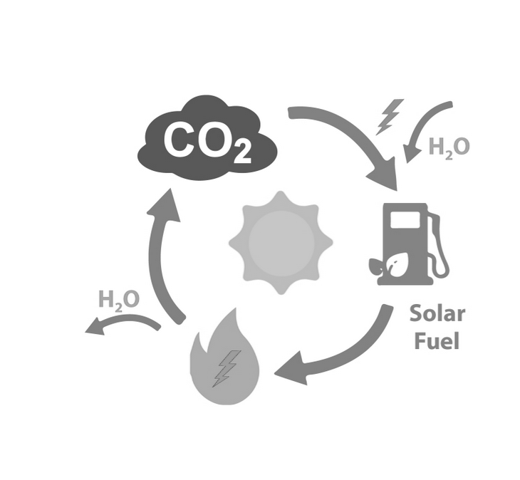Main body of text. Please keep all formatting as it is given in this template. This is Arial, font size 11, line spacing 1.15, justified. Give your references in square brackets and as superscripts. Images or graphics can be included as black-and-white pictures of high resolution Figures and may be referenced in the text (Figure 1).

Figure 1: Caption text.
The abstract should fit on one page, not extending below the Notes line.
Submit your abstract as a PDF file to the online form there: https://solarfuels.cnrs.fr/evenement/reunion-annuelle-2022/#soumission

References
[1] References must be formatted, example below.
[2] A. Author, B. Author, C. D. Author, Journal. Name. year, volume, page-page.
[3] A. Author, B. Author, Book Chapter Title, Publisher, City, year.

